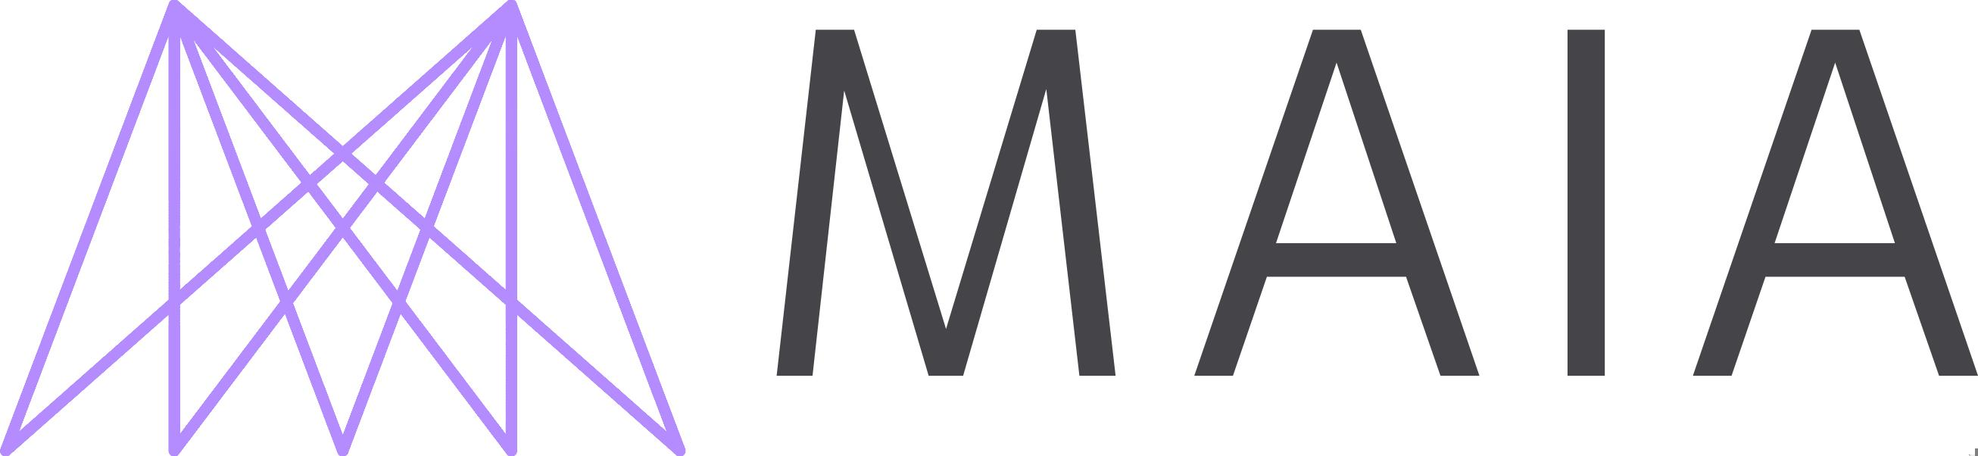

AI Safety Fundamentals Gov

Fall 2023

[ WEEK 4 ]

**Compute governance**

READINGS

|  |  |  |
| --- | --- | --- |
| *Introduction to compute governance*  *(Outline; Summary; § 1 2)*  *(Heim, 2023)* | *Verifying rules on large-scale neural network training via compute monitoring*  *(pp 1-6 § 7)*  *(Shavit, 2023)* | *Choking off China’s access to the future of AI*  *()*  *(Allen, 2022)* |